Calendar and reminders

Whether you want to remind yourself of a method/task or a co-worker, LabLog can assist. You can assign tasks to team members simply to remind or to track due dates and responsibilities. Additionally, you can use the calendar function to schedule meetings for yourself and colleagues.

Once the reminder is placed and/or an assignment has been scheduled, the LabLog dashboard keeps track of total tasks and scheduled methods. Quickly viewing your dashboard helps you stay informed as shown in example below. You will receive an email notification 24 hours before a reminder is due. If you have signed in the mobile app you will receive mobile push notifications for your reminders.

Moreover, the LabLog calendar can be integrated into external calendars including Google Calendars.

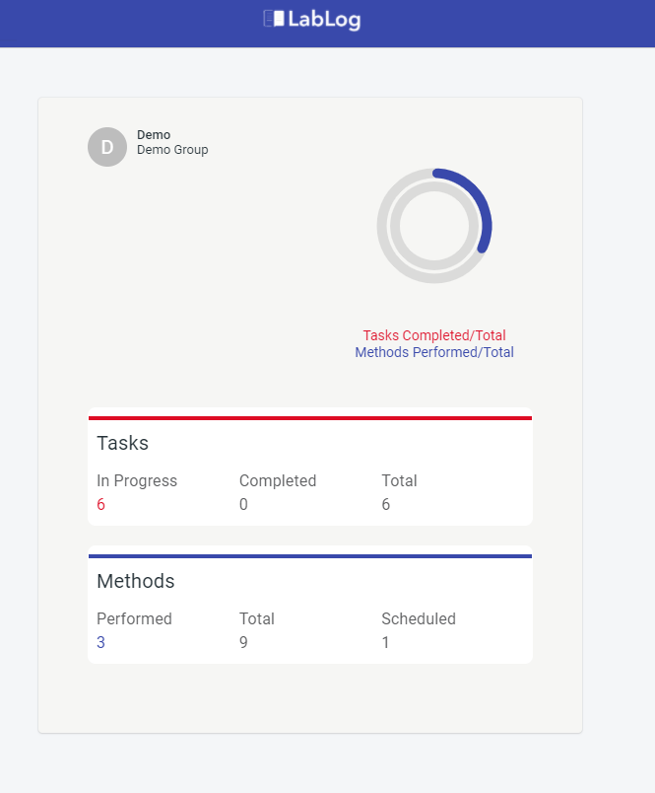

Having this organization built into the same software utilized for methods, tasks, inventory, and document management saves time and simplifies your daily life in the laboratory. You will never miss a meeting or due date again!

**Creating a reminder from a method or task**

To remind yourself of a method or task to complete, simply follow these steps whether in the Method or Task module of LabLog:

1. Click on the “Remind Me” icon in the top tool bar.



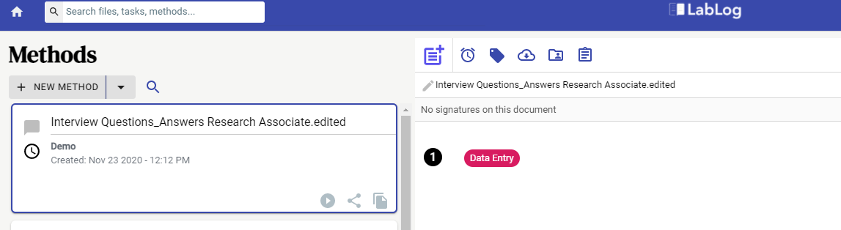

1. Add the date and time and any comments for the reminder, then click “Add Reminder”.

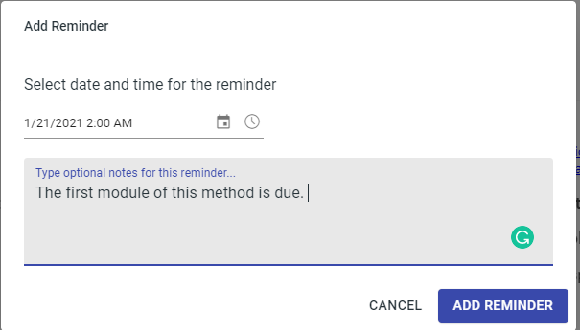

The dashboard keeps track of the number of methods and tasks that need to be completed. You will receive an email notification 24 hours before a reminder is due

**Creating a reminder from inside the calendar**

You have the option to go directly to the date and time within the calendar to add reminders or appointments. Utilizing this function allows you to share with others on your team. To schedule, click on the date and time of reminder/meeting and complete the “New Event” details box as seen below.

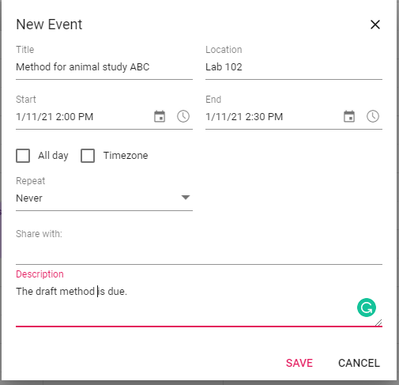

If you want the event to specifically say “reminder for,” you can drag the “Reminder” icon on the left hand side of the calendar to the specific date and time on the calendar and then complete the rest of the “New Event” details.

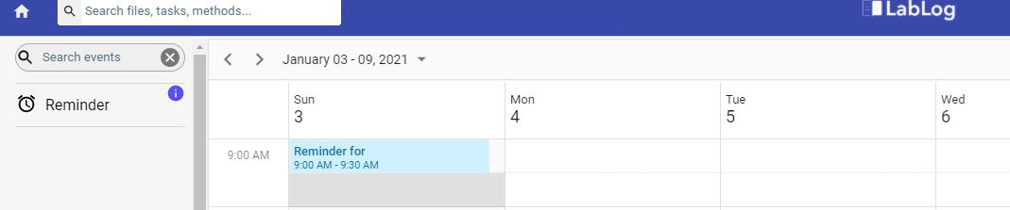

**Creating a meeting with co-workers**

Once you have team members added to the LabLog software, you can schedule meetings with them by following the same steps in the “Creating a reminder from inside the calendar” above. Add team members to the “Share with” section within the “New Event” details box.

**Create Task and Assign – Task Reminders**

Methods can be assigned to team a member which then becomes a task for the team member/s assigned to the method. A reminder is created when a method is assigned. To create and set reminder for a task, follow these steps:

1. Click on the share and more option at the bottom of specific method you want to create task and assign.

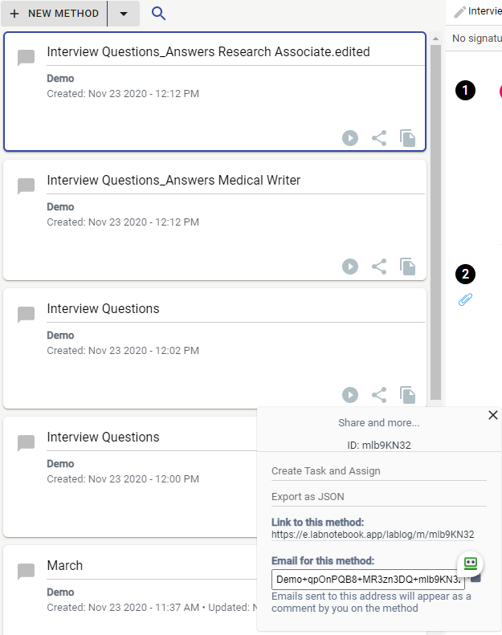

1. Assign to a team member and set a reminder using the screen below once you have selected the “Create Task and Assign” option. Note: You can assign to yourself as well.

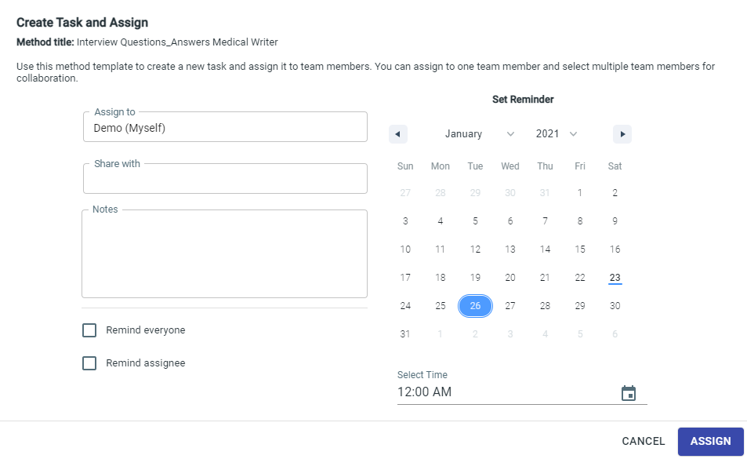

Once the method has been assigned to an individual, it will appear as a task for that person and a reminder is set on their calendar.